Final Report for the Project Japanese spiraea removal at the Rheinstrom Hill Audubon Sanctuary

The project to remove Japanese spiraea for the Rheinstrom Hill Audubon Sanctuary was successfully completed. All of the originally known individuals as well as all of the individuals discovered through the surveys were treated. The plants that had been previously planted were all dug out, and the plants that were found in the wooded areas around the original planting were cut multiple times or dug out, depending on their location and surrounding vegetation. The plants that were cut multiple times throughout the year were cut in May, July, August, and October. The survey area that led away from the original plantings, down the small creek was very informative. Only a few individuals were found near the plantings, but none was found further downstream.
There were many individuals found to the north of the plantings, along an old access road that were unexpected. Along with many of the previously known individuals being found down the road and along the trails indicates that the most likely vector for spread is people, with seeds being transported on boots or equipment instead of down the stream.
All of the treatments and observations were uploaded into iMap. The treatment record is 21902.
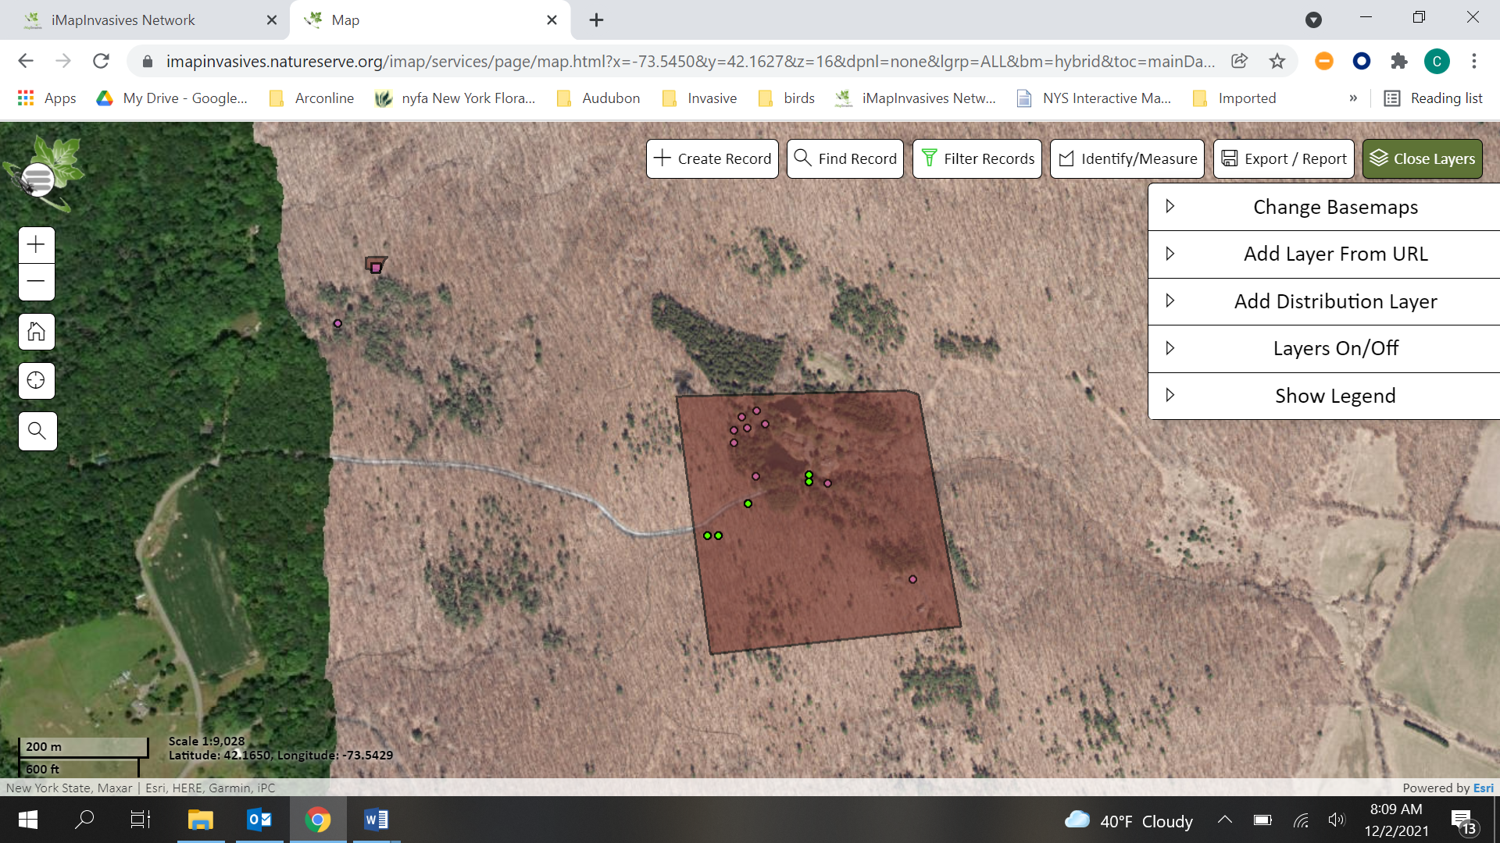

Pre treatment
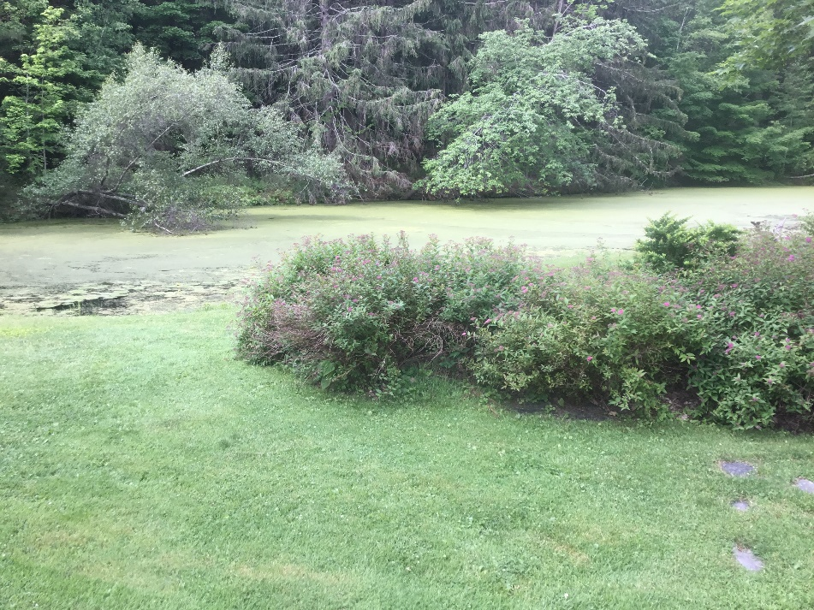
Post Treatment

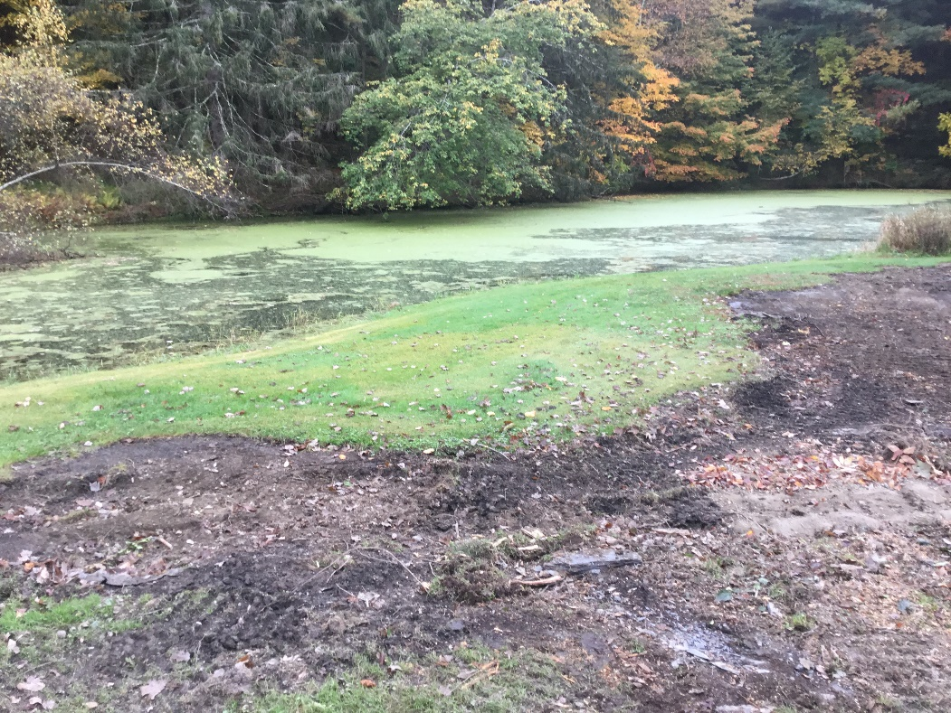

Pre-Treatment
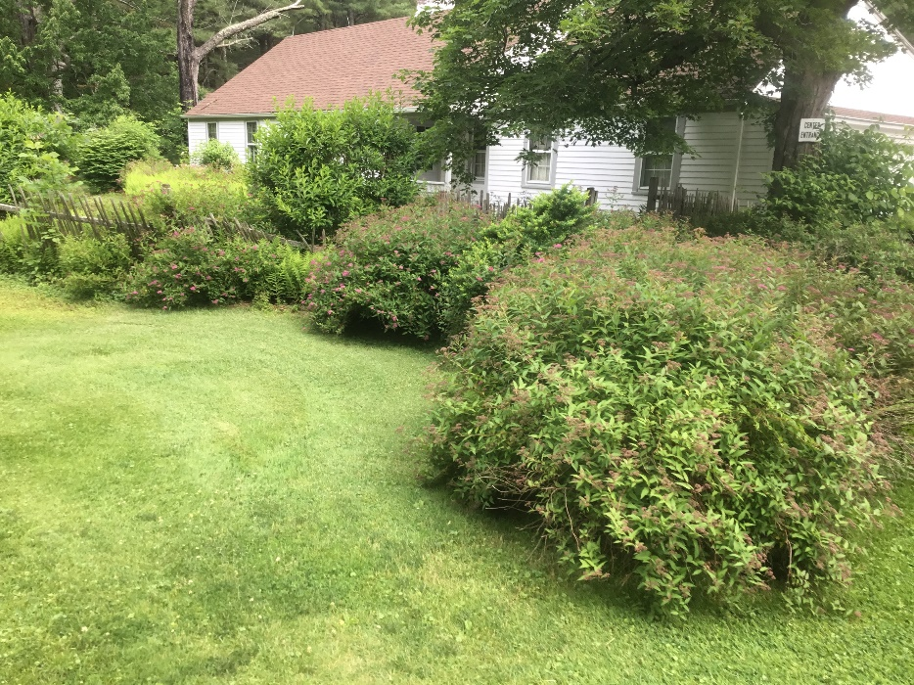

Post-Treatment
