Water Chestnut (Trapa natans) Response Guidelines
for Manual Removal Efforts
Waterfront Properties, Lake Associations, and Volunteers
The following Aquatic Invasive Species (AIS) Response Guideline outlines the steps for the manual control of water chestnut infestations of smaller size. This document is intended to reach waterfront homeowners and related organizations who are seeking to act and respond to water chestnut (Trapa natans), a high threat aquatic invasive species. This document can additionally serve as a guide for waterfront properties, lake associations and groups seeking to conduct volunteer work. Entities seeking to control large infestations of water chestnut may find better suited information in the “Mechanical Response Guidelines” offered by the Capital Region PRISM. Goals and justifications for conducting a manual response should be well defined with clear objectives. The following document will describe the process involved for a safe and successful response.
The Capital Region Partnership for Invasive Species Management (CR-PRISM) is a collaborative organization created to address the threat of invasive species. CR-PRISM is a not-for-profit quasi-governmental agency hosted by Cornell Cooperative Extension of Saratoga County. The CR-PRISM strategically operates across eleven counties and is financially supported by the Environmental Protection Fund as administered by the New York State Department of Environmental Conservation (NYS DEC). The CR-PRISM is one of eight Partnerships for Regional Invasive Species Management in New York State. The CR-PRISM works in collaboration with partner groups to promote prevention, education, and outreach strategies, create early detection and response networks, and execute best management practices for invasive species control including post-treatment monitoring and restoration actions. The goal of these efforts is to protect conservation targets within our communities and slow the spread of aquatic and terrestrial invasive species.

Topics in this response guideline includes information such as
- Statement of problem, water chestnut biology, and background
- How to conduct a water chestnut pull and management considerations
- Capital Region PRISM Framework of Response and prioritization
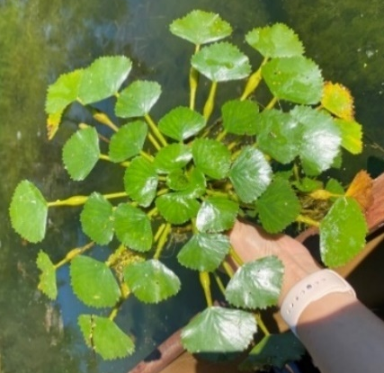
Step 1. Identifying Management Goal and Objectives
Step 2. Determine the Size and Distribution of the Infestation
Step 3. Permissions and Permitting
Step 4. Equipment, Materials and Safety
Step 5. Scheduling Event
Step 6. Methodology
Step 7. Disposal and Permitting
Step 8. Volunteer Recruitment and Engagement

Statement of Problem, Water Chestnut Biology, and Background
Water chestnut (Trapa natans) colonizes areas of freshwater lakes and ponds and slow-moving streams and rivers, where it can form dense mats of floating vegetation. These floating dense mats are referred to as monocultures, which cause problems for boaters and swimmers, and negatively impacts aquatic ecosystem functions. Monocultures can cause a decrease of dissolved oxygen content in the water column, alter submersed plant and animal communities, and reduce the biodiversity by outcompeting native aquatic plants. Water chestnut may reduce real estate values and economically impact businesses and marinas. The aquatic invasive plant has been introduced to the northeast for over a century and is widespread. Water chestnut grows in the littoral zone; this is the shallow area surrounding a waterbody that leads to land.
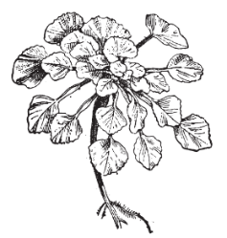
Water chestnut is an annual, rooted floating aquatic invasive plant species. It has both submerged and floating leaves which are different in appearance. Submerged leaves are feather-like and somewhat delicate, and can resemble a milfoil; floating leaves are more easily identifiable with triangular toothed edged floating rosettes. The rosette surrounds a central stem, and leaves are structured with inflated petioles which allow the rosette to float. The plants preferred depth is 0.3-2.0 meters and can grow up to 5 meters. Water chestnut typically surfaces in late May to mid-June in the Capital Region.
Each rosette has the capacity to produce 20 seeds (also known as fruits or nutlets). Mature seeds are lighter green and typically mature by late July to mid-August within the CR-PRISM. The seeds are easily identifiable with four sharp barbs. These barbs easily attach to items, causing vectors of transportation including: waterfowl, floating dispersal, boats/trailers, fishing equipment, and improper disposal. Seeds fall from the rosette into the sediment below and are viable for up to 12 years. Seeds which build up in the sediment below are referred to as a “seed bank”. The longer the amount of time an infestation is present the greater the seed bank; management of this species requires long-term commitment as just one plant can reinstate the initial population.
Water chestnut is a New York State Prohibited Invasive Species and cannot be knowingly possessed with the intent to sell, import, purchase, transport or introduce. The New York State Natural Heritage Program Tier Rankings lists water chestnut as a high threat tier four (widespread) aquatic invasive species with significant negative impacts. The Aquatic Invasive Species (AIS) Spread Prevention regulation, or 6 NYCRR Part 576, is a statewide regulation that requires reasonable precautions, such as cleaning, draining and treating, and drying are taken to prevent the spread of AIS prior to placing watercraft or floating docks into public waterbodies.

How to Conduct a Manual Water Chestnut Pull & Management Considerations
Capital Region PRISM Framework of Response and Prioritization
Water chestnut responses are conducted on a limited basis each year at priority locations by the CR-PRISM. Response locations are internally guided using a Water Chestnut Prioritization. All partner and public requests for water chestnut removals are considered. CR-PRISM water chestnut removals are typically justified using three factors: ecological significance, public benefit/economic value, and emergency access. The size, density, and longevity of preexisting sites are also considered. Populations less than .5 acres in size can typically be locally eradicated using manual pulling techniques. Larger populations with high densities require mechanical (harvesters/hydro rakes) or chemical controls. In all cases, control requires commitment, resources to perform the work, and costs over time. The CR-PRISM can assist in helping entities seeking to conduct AIS removals. When appropriate, the CR-PRISM has aided in formulating applications for grants. Establishing an annual volunteer base who can assist in a manual pull, is also factored in the decision-making process.

Step 1: Identifying Management Goal and Objectives
Stating clearly defined goal(s) and objectives is important in the planning stages of conducting a water chestnut pull. Success is dependent on setting realistic targets for removal, identifying available resources such as volunteers and related partner groups who can help, as well as a clear scope of work that has been defined.
Goals can range from creating an access path, clearing a dock or boat launch, slowing the spread of an infestation in a specific area, suppressing efforts to reduce the size of a current population, or local eradication.
Please consider that the seed bank for water chestnut can be viable for up to twelve years. Removal efforts will require commitment over time to continue harvesting plants to deplete the seed bank. Impacts of the removal at the immediate local level are usually apparent after 2-3 years depending on the size of the infestation. When stating a project goal consider incorporating several manual hand harvesting events over time in the first few years and track the success of your work.
Example goals:
        - Clear an area for recreational purposes
        - Create a pathway for emergency access
        - Clear a boat launch, slip, or floating dock
        - To protect a conservation target or threatened species in critical habitat
        - To prevent the spread of the aquatic invasive species into an uninvaded area
        - Identify potential dates over multiple years for conducting a manual hand pull

Step 2. Determine the Size and Distribution of the Infestation
Setting a goal requires one to assess the size and extent of the infestation targeted for removal. Manual management of an existing population should be less than an acre depending on the number of participants and time available for hand pulling events. If the infestation is larger than an acre, please consult the CR-PRISM Water Chestnut Guidelines for Mechanical Harvesting.
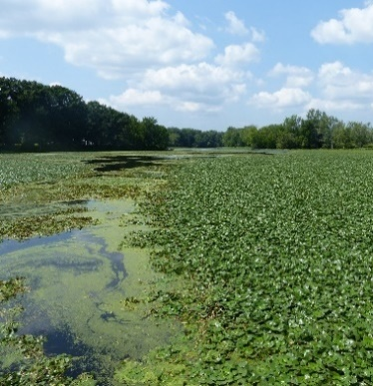
Documenting the size of the infestation will aid in understanding the best management approach, feasibility, time required, and knowing the effectiveness of those actions for the years to come. Documentation can help determine if hand pulling efforts are an effective response based on the goal. To determine the size and distribution, a small watercraft may be required or shoreline access. A step-by-step guide is available on the iMapInvasives, Documenting Water Chestnut Efforts webpage. iMapInvasives is a free statewide database for reporting invasive species and management. Alternatively, an estimate of acreage can be determined by visiting the infestation site while cross referencing one’s location to Google Maps. The CR-PRISM is available on a limited basis to assist with the initial delineation of an infestation.

Step 3. Check for Permissions and Permitting to Perform the Work
All permits should be obtained three months prior to an activity. Access points and permissions should also be secured depending on ownership. Dependent on the type of waterbody, private, local, state, and/or federal permits may or may not be needed. The lead entity is responsible for obtaining the proper permits. Consult with the New York State Department of Environmental Conservation Regional Permitting Office to determine the correct permits if applicable.
Secure written permission from all property owners from access points, right aways, and landowners including those who own property below the water’s surface. Identify and follow all local municipality ordinances.
Check for Rare, Threatened, or Endangered Species. Contact the New York State Natural Heritage Program or discuss with your local PRISM to determine if species of concern or high conservation values are present to take necessary precautions as to not harm them.

Resources for Permitting
1. DEC Statewide Offices Contact Information
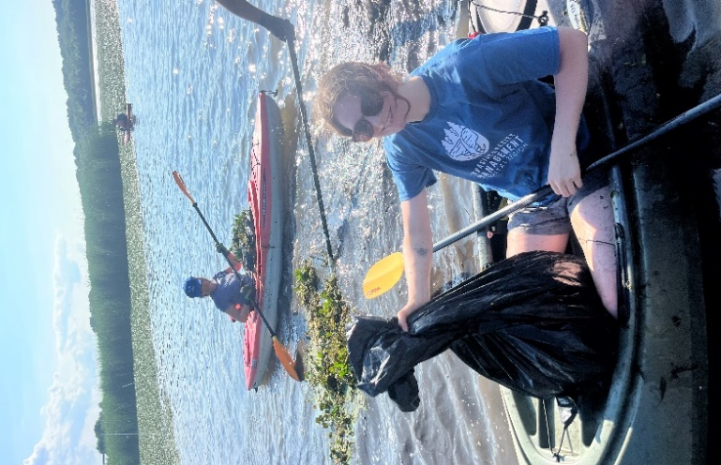
- For questions contact your Regional NYS DEC Permit Administrator!

2. General Permit for Management of Invasive Species
- Types of: General Permit For the Management of Invasive Species (GP-0-15-005/GP-0-21-004)
- General Permit Application: GP-0-21-004
- Protection of Waters Program: Article 15

3. Freshwater Wetlands Permitting
- ECL Article 24 Freshwater Wetlands
- Freshwater Wetlands Joint Application Form

4. The Environmental Resource Mapper (ERM) can be used to identify protected streams based on their classification and to create simple maps as part of the permit application process if needed.
5. Additional permitting may be required for disposal and/or transportation of plant material. Please refer to the end of this document for additional information.

Step 4. Equipment, Materials and Safety
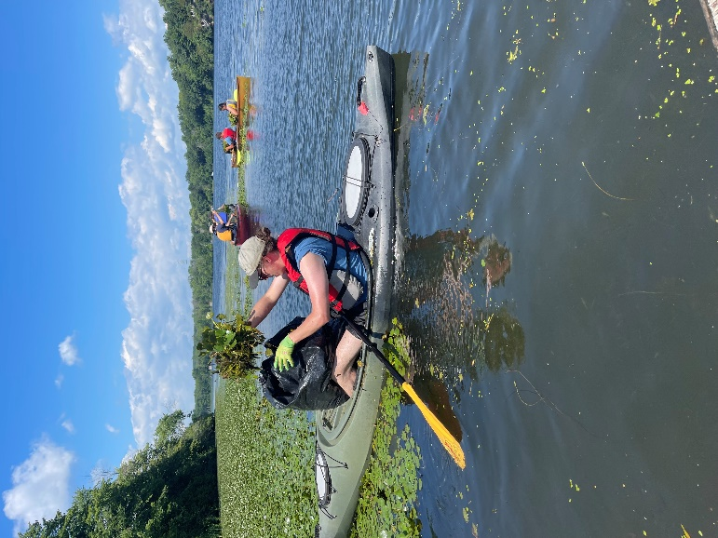
- Procure watercraft to assist with the manual pull such as kayaks, canoes, and small rowboats. Motorized boats can be extremely helpful for collecting and transporting biomass to a central location for disposal. Attendants on the boat can serve as safety guides.
- Collection method while on watercraft such as contractor garbage bags or laundry baskets.
- Gloves, hats, sunscreen and personal flotation devices.
- Food and water.
- Truck with cover to transport AIS and meet permit transportation requirements.
- Provide PPE like life preservers, have a first aid kit available, and manager on the water to supervise safety issues and workflow.
- Monitor forecasts and set a rain date with inclement weather.

Step 5. Scheduling Event

Early in the season (May/June) it is best to collect the rosette and root system of the plant to prevent vegetative regrowth.
- Seeds at this point will be immature and still secured to the floating rosette
- This method can produce high levels of turbidity effecting water quality, especially with large pulls and many volunteers

Mid to Late Season (July/August)
- Seeds may be maturing and not fully secured to the floating rosette.
- Consider pulling and separating the top portion of the plant or cutting the rosette at the base.
- Will reduce the likelihood of turbid waters.

Late Season (mid-August to early September)
- Mature seeds will start to fall from the rosette in Late July to Early September. Management during this time is ineffective. The timing of seed fall can be site dependent.

Consider conducting pulls in a 3-5-hour window using the steps below as a guideline:
- Premeeting with all parties involved, outlining the objectives and safety measures of the activity.
- Identify site specific safety concerns.
- Review designated approach to the hand harvest (i.e. where to focus efforts as a group)
- Schedule multiple breaks out of the watercraft.
- Recommend for participants to bring extra clothes for after.
- Monitor weather forecasts and plan a rain date as needed.

Step 6. Methodology
With a selected goal and control strategy in hand, prioritize the work effort. Efforts are best served when beginning with low density satellite populations, then moving into the core of an infestation or monoculture.
- Strategy prevents smaller, manageable infestations from becoming larger.
- This strategy starts with less difficult manual removals to those more intensive, expensive, and time consuming.

The New York State Department of Environmental Conservation “Managing Invasive Plants in Riparian Areas”

Identify the outer edge of the plant bed and work inward towards the center of the population over time, making sure to remove trace/sparse amounts that are away from the larger floating mat(s). Consider 2-4 harvests in a single year depending on time commitment and support. Repeat yearly at the same location to reduce the size of the infestation. Over time the seed bank will decrease, and response efforts will be able to become less frequent. Please note that upstream sources of water chestnut may serve as a seed source and continued efforts will be needed. In such cases maintenance of a plant bed for annual weeding may be the management goal.

Step 7. Disposal Permitting

Additional permits may be needed for the proper disposal of invasive species and should be considered in the beginning stages of planning.
- Application and permit to: Possess with Intent to Sell, Import, Purchase, Transport, or Introduce a Prohibited Invasive Species for Research, Education, or Other Approved Activity.
- Check with your regional NYS DEC Permitting Office to see if this is needed. Permit is attached in the Appendix.
The disposal method for permitting should describe the release location, or the methods you will use to dispose of the listed invasive species. Proposed disposal methods and protocols should render the invasive species non-viable and prevent the re-introduction and spread of the invasive species during transport to a disposal facility.

When disposing of AIS consider the following:
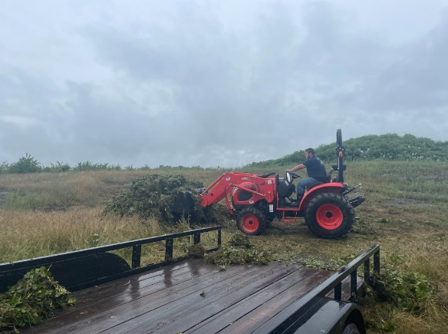
Securing a vehicle to transport aquatic invasive species biomass.
  - AIS should be covered or contained during transport
  - Decontamination of equipment using high pressure hot water (140 Degrees $℉$)
  - Identify fees for needed disposal and build into a budget
A site for disposal must be identified prior to management
- Consider composting with a local municipality
- Burial as compost with a local farm
- Burial at a reclamation/recovery site for retired mines
- Processed as biofuel if a biodigester is present
Disposal of water chestnut should be organized roughly one month prior to the removal. It is recommended that points of contact for disposal be provided with an estimated biomass amount and drop off timeframe. Multiple trips to the disposal site may be necessary. Disposal locations vary. If the biomass does not pose a risk of reintroduction to a waterbody, it can be left to dry in hot weather over time. Compost facilities at municipality transfer stations accept this material on a limited basis, it is recommended to contact your local facility. Farmers/landowners will also occasionally accept the material if there is need for compost.

Step 8. Volunteer Recruitment and Engagement

Volunteers who have a vested interest in the local environment are critical for success and need to be recruited and organized. Local community members should be recruited through different media channels.
  - Begin with identifying a date and time that is favorable to recruit the most participants, designate a rain date.

  - Advertise the event through multiple platforms.

  - Instruct volunteers on what to bring. Food, water, personal protective equipment, personal watercraft.

  - Sign volunteers in and have a safety meeting the day of the event. Review site specific safety concerns.

  - Have volunteers sign a waiver of liability to participate.

  - Demonstrate clean, drain, dry practices before and after the event.

